CPE301 – SPRING 2019

Design Assignment 3b

Student Name: Do Le

Student #: 2001183621

Student Email: led2@unlv.nevada.edu

Primary Github address: <https://github.com/DoVietLe>

Directory: <https://github.com/DoVietLe/assignments>

The goal of the assignment is to modify the above codes to do the following:

1. Write a C AVR program that will monitor the LM34/35 connected to an Analog pin (PC5 or PC0) to display the temperature in Centigrade (C) and Fahrenheit (F) on the serial terminal every 0.5 sec. Use a timer with interrupt for the 0.1 sec delay and use a counter variable to implement the 0.5 sec delay. Use a FTDI chip for serial to USB conversion and display the values in the terminal.

2. Use the ATMEL Studio Data Visualizer or any Charting program to display the values in time.

1. **COMPONENTS LIST AND CONNECTION BLOCK DIAGRAM w/ PINS**

Components

• ATmega328PB Xplained Mini Board

• Atmel Studio 7.0

* Compiler
* Serial Monitor
* Data Visualizer

• LM35 Temperature Sensor

• Resistor (100Ω)

• Breadboard

Block Diagram

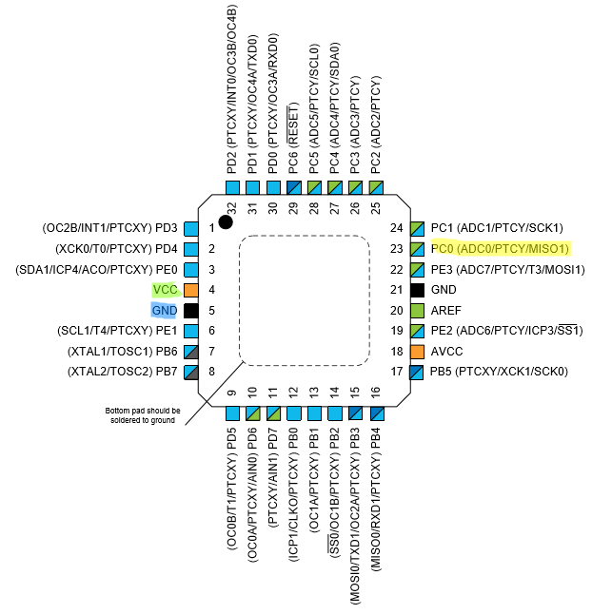

Figure : Pinout

PC0 Used as ADC0.

1. **INITIAL/MODIFIED/DEVELOPED CODE OF TASK 1/A**

Task 1 Code

#include <avr/interrupt.h>

#include <avr/io.h>

#define UBBR_VALUE 103

#define CYCLES_100ms 6249

volatile char cTempString[10];

volatile char fTempString[10];

volatile int passes = 0;

void setTimerAndInterrupts() {

// Set interrupt settings.

OCR1A = CYCLES_100ms;

TIMSK1 = 0b00000010; // Enables interrupt on compare match A.

TIFR1 |= 0x02; // Clears the interrupt flag.

sei();

// Sets timer settings.

TCCR1B = 0b00001100; // Sets timer1 to be in CTC mode with 256 pre-scaler.

TCCR1A = 0b00000000;

TCNT1 = 0;

}

// Enables the UART and it's transmitter.

void enableTransmit() {

// Sets port.

DDRD = 0x02;

// Sets baud rate.

UBRR0 = UBBR_VALUE;

// Sets UART settings.

UCSR0C = 0b00000110; // to async mode with no parity

// 2 stop bits, and a frame of 8 bits.

UCSR0B = 0b00001000; // Enables transmit line.

}

// Disables the transmitter on UART.

void disableTransmit() {

UCSR0B &= ~(1<<TXEN0);

}

// Sends one byte of data out the TX line.

void sendByte(*uint8_t* b) {

if (UCSR0B & (1<<TXEN0)) { // Checks whether transmit is enabled.

while (!(UCSR0A & (1<<UDRE0))); // Waits until the UDR0 register is ready.

UDR0 = b; // Sends the byte.

}

}

void sendString(char string[]) {

int i = 0;

while (string[i] != '\0')

sendByte(string[i++]);

}

void enableADC() {

// Sets PINC0 as input.

DDRC &= ~1;

// Sets up ADC settings.

ADMUX = 0xC0; // Reads from ADC0. Right justified. Internal 1.1V reference.

ADCSRB = 0x00; // Free running mode.

ADCSRA = 0b10000111; // Enables ADC with 128 pre-scaler.

}

void disableADC() {

ADCSRA &= 0x7F; // Disables the ADEN bit.

}

*uint16_t* analogRead() {

ADCSRA |= (1<<6); // Enables ADSC to start AD conversion.

while (!(ADCSRA&(1<<4))); // Waits until ADIF is set indicating ADC is done.

ADCSRA |= (1<<4); // Clears ADIF flag.

return ADC; // Returns value.

}

float analogToTemp(*uint16_t* t, char unit) {

// Takes analog converted number and converts it into temperature.

//return t;

float convertedTemp = t*110/1023;

switch (unit) {

case 'C':

case 'c':

return convertedTemp; // Returns temperature converted to fahrenheit.

case 'F':

case 'f':

default:

return convertedTemp*1.8 + 32; // Returns temperature converted to celsius.

}

}

int main(void) {

// Enables resources.

enableTransmit();

enableADC();

setTimerAndInterrupts();

while (1)

// When five 100ms passes occurs, send the data.

if (passes >= 5) {

passes = 0;

// Reads in data and converts it to celsius and temperature.

*uint16_t* temp = analogRead();

float cTemp = analogToTemp(temp, 'C');

float fTemp = analogToTemp(temp, 'F');

// Converts the floats into strings.

*snprintf*(cTempString, 10, "%f", cTemp);

*snprintf*(fTempString, 10, "%f", fTemp);

// Sends the data serially.

sendString("Temperature Celsius: ");

sendByte(cTempString);

sendString(" Fahrenheit: ");

sendString(fTempString);

sendByte('\r');

sendByte('\n');

}

}

// Increments the amount of 100ms that passes.

ISR(TIMER1_COMPA_vect) {

TIFR1 |= 0x02; // Clears the interrupt flag.

passes++;

}

1. **DEVELOPED MODIFIED CODE OF TASK 2/A from TASK 1/A**

No code (see part 5 for chart).

1. **SCHEMATICS**

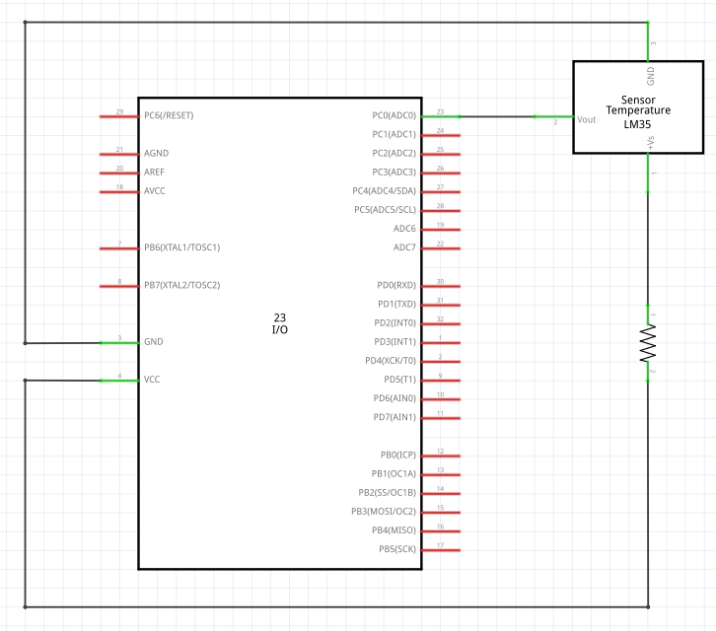

Figure : Circuit setup

1. **SCREENSHOTS OF EACH TASK OUTPUT (ATMEL STUDIO OUTPUT)**

Task 2 Chart

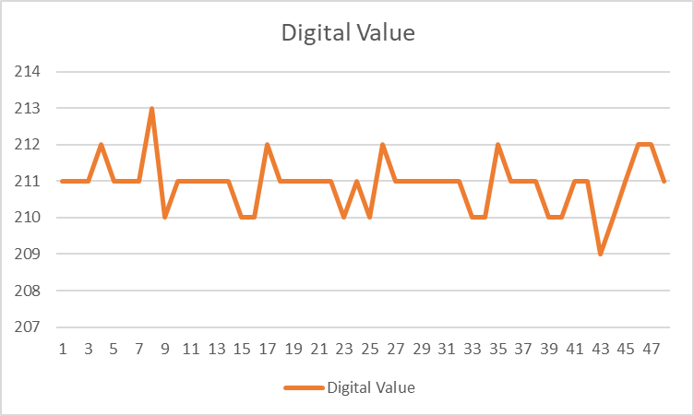

Figure : Chart displaying digital value from analog ADC over time

1. **SCREENSHOT OF EACH DEMO (BOARD SETUP)**

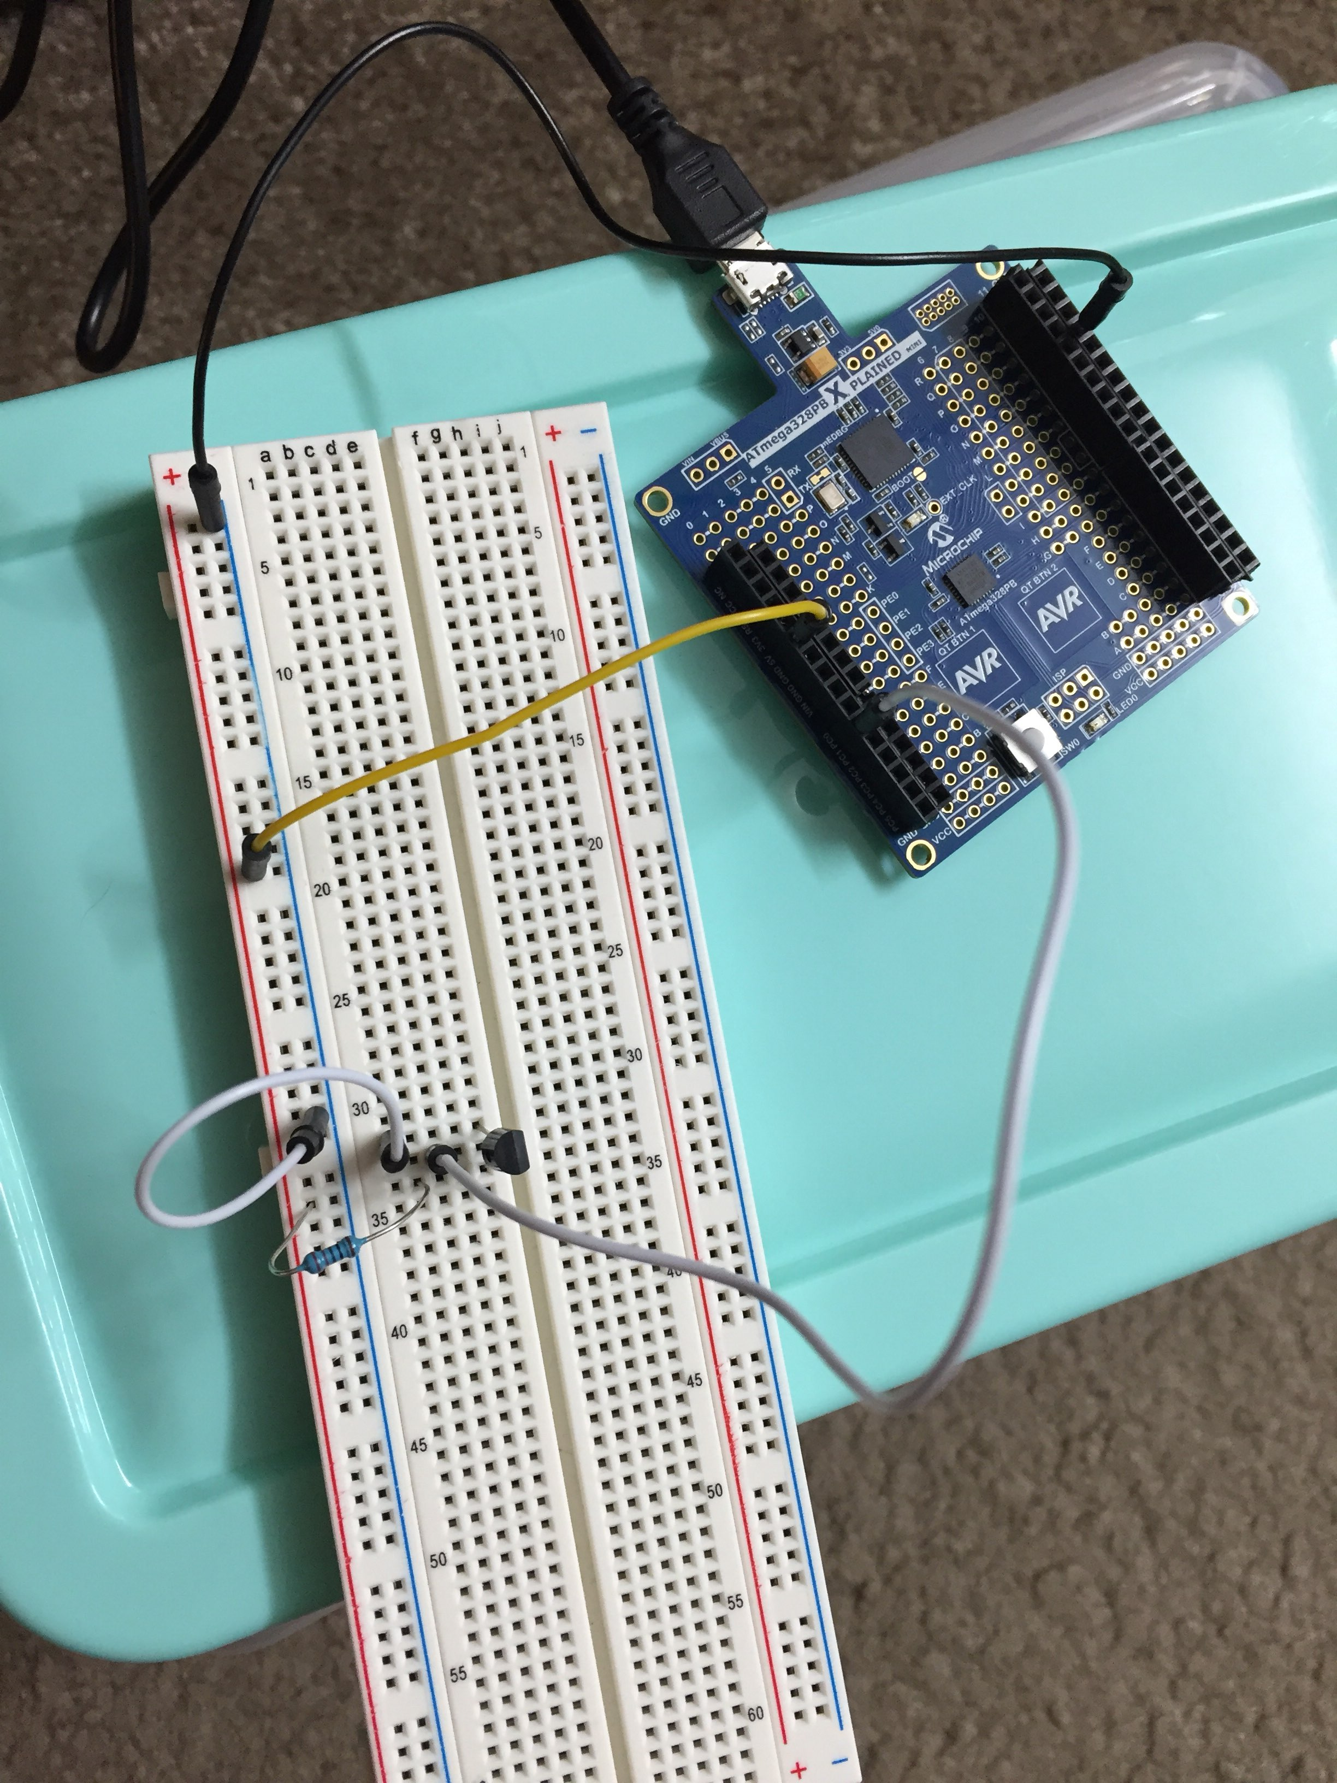

Figure : Board setup

1. **VIDEO LINKS OF EACH DEMO**

Task 1

https://www.youtube.com/watch?v=yNBYixBSzdg

1. **GITHUB LINK OF THIS DA**

https://github.com/DoVietLe/assignments/tree/master/ESD301/LAB03b

**Student Academic Misconduct Policy**

<http://studentconduct.unlv.edu/misconduct/policy.html>

“This assignment submission is my own, original work”.

Do V. Le